Sections

Optimum Ticket Price Model for Big Mountain Resort

# Introduction

Big Mountain Resort hosts 350,000 visitors each season and boasts 105 trails including the longest 3.3 mi Hellfire trail. A market investigation was requested to ask the question how Big Mountain’s ticket prices fair against other resort prices. With a recent addition of another chair lift the operating cost has increased by $1.5Mil. Although a single cost figure is provided, there was insufficient data given to estimate detailed expenses of the resort. This report provides model results to predict ticket price and make model-supported recommendations to increase revenue.

# Methodology

A single dataset in .csv form with 21 columns and 330 different resorts. The dataset included features each resort had including: summit elevation, vertical drop, number of fastQuads, the longest run, and weekend and weekday ticket prices. The dataset was read and investigated using Pandas, a python library for performing data analysis.

Several issues with the dataset included missing ticket prices, incorrect values for year, and discrepancy between region and state were overcome. A workable dataset was then explored. A heat map shows that the price is correlated to ‘fastQuads’, ‘Runs’, ‘Vertical Drop’, etc.

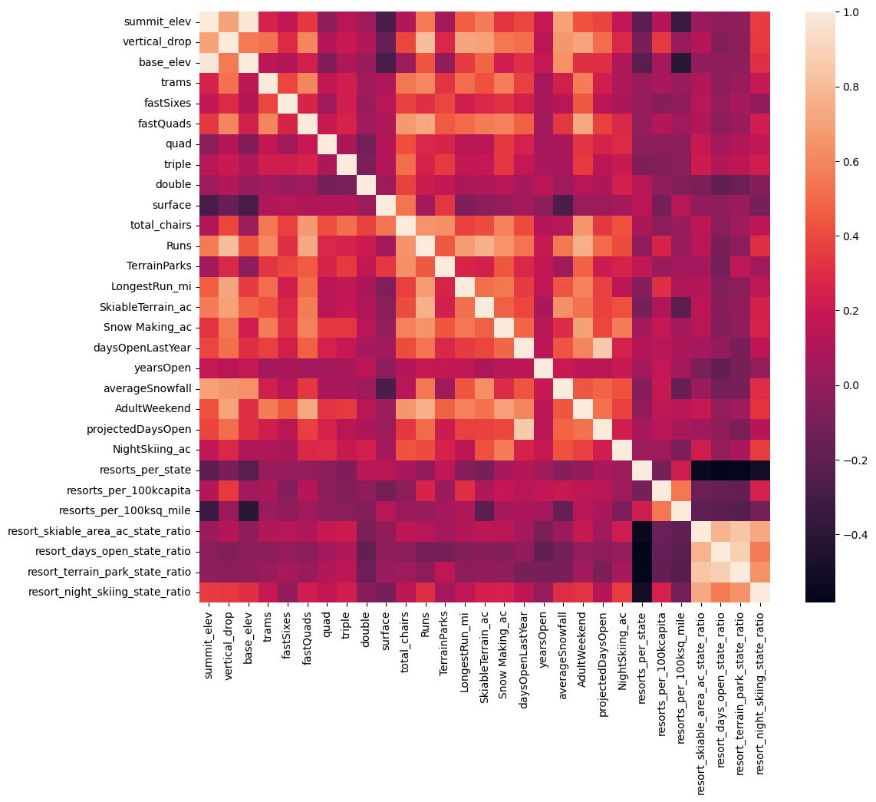

# Recommendation

Big Mountain is already the highest priced ski resort within MT but it also boasts being in 4th quartile in terms of skiable terrain, number of runs, and vertical drop. For those reasons, there exists a case to increase ticket prices especially if additional chair lifts are installed. Big mountain currently charges $81/day. Based on the random forest model, the price prediction in comparison to all other resorts show that the price could be $100.03 with an absolute error of $10.37. Based on the results, I would recommend safely increasing the ticket price by $9 to $90/day. Assuming 350k visitors with a 5 day average ski days, this will increase resort revenue by 15Mil (~11%) while staying under the lower bounds of the model error.

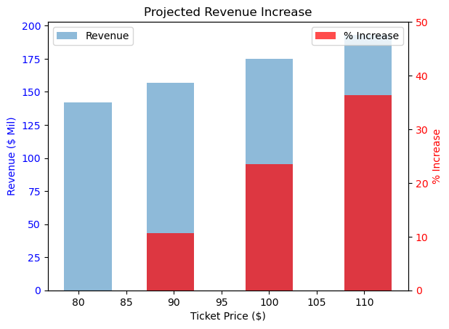

Big mountain, in comparison to other resorts, is on the upper end of the total number of runs and the longest run. It was found that only increasing the chair frequency by 1 had an effect of increasing revenue by $1Mil but would increase operating cost by $1.5Mil. Therefore overall, there exists a business justification of increasing ticket prices to supplement chair frequency and adding vertical drop to ski trails. Based on the model, closing a few runs would reduce revenue but also results in, since the data is unavailable, unknown reduction of operating costs. There is a plateau at 2-3 runs closed that reduces revenue by $1.5Mil while closing 4-8 runs decreases revenue by $2.5Mil. A phased closure of ski trails is recommended to observe effects.

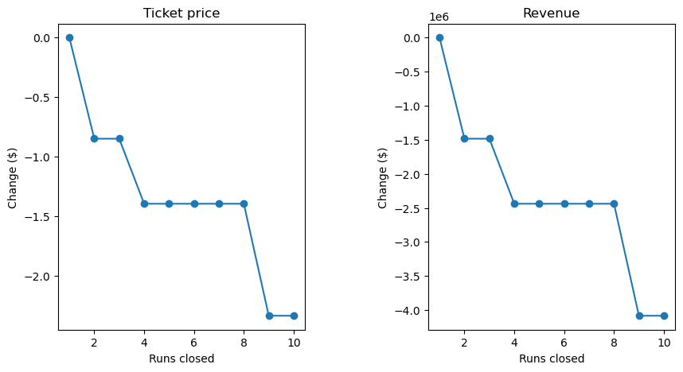

# Future Work

The revenue was calculated by assuming 350k visitors with 5 ski days on average. A better prediction of revenue can be made with more data on ticket sales. Costs of operating chair lifts, maintaining trails, and running the snow making machine would improve the quality of revenue projections. Since an exhaustive list of scenarios was not explored in this investigation, a dashboard linking the ML model with various features would allow the executive team to dream up alternative scenarios.